CPSC 335 722/2021
- Divide and Conquer
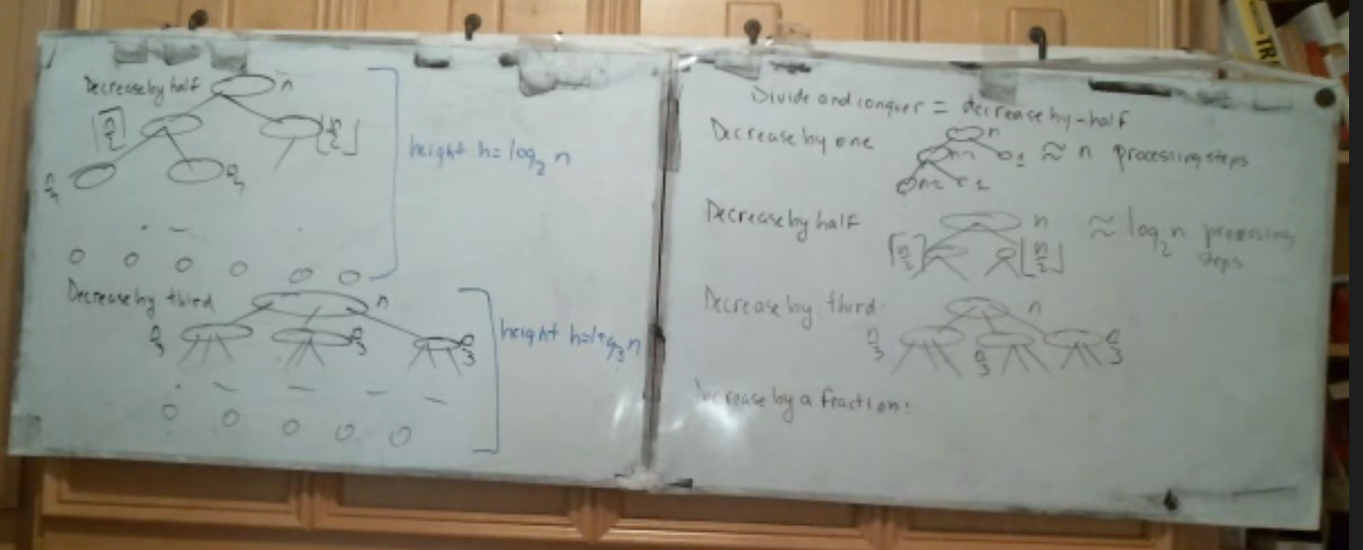
  - Summation problem
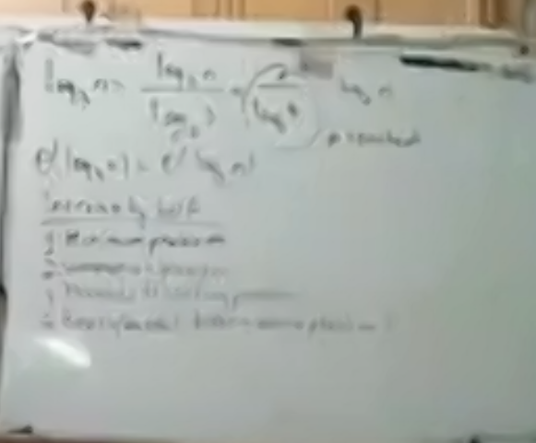
  - Pseudocode
- a
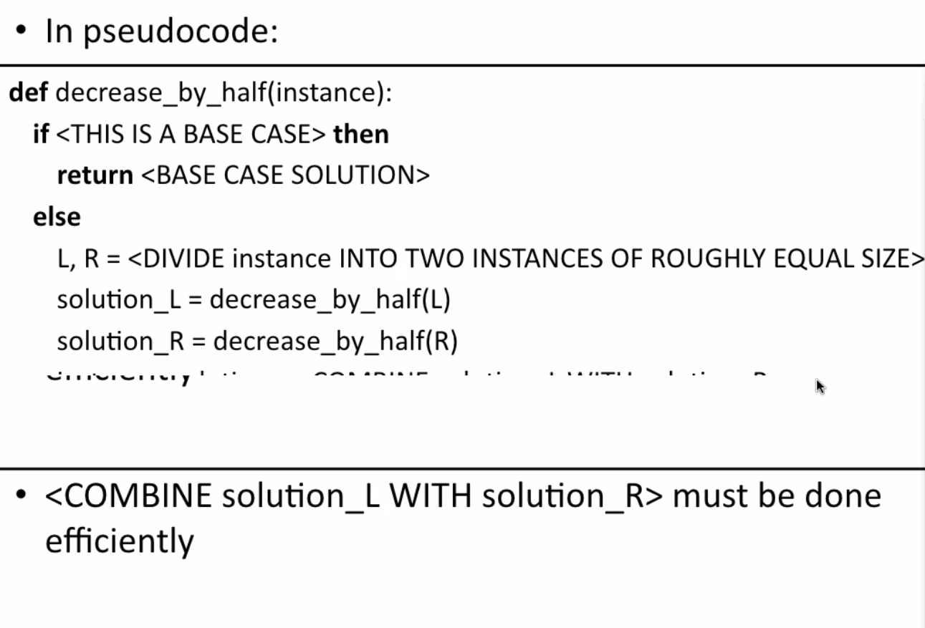
- Pseudocode
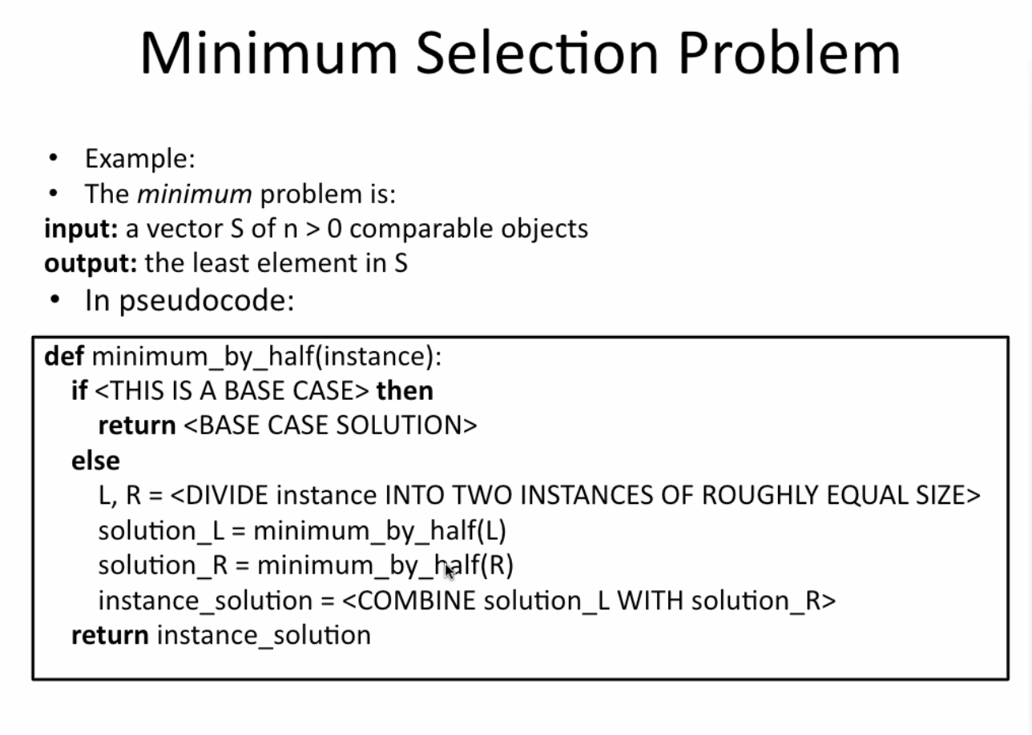
- Minimum Selection Problem
- Array is split into 2 halves
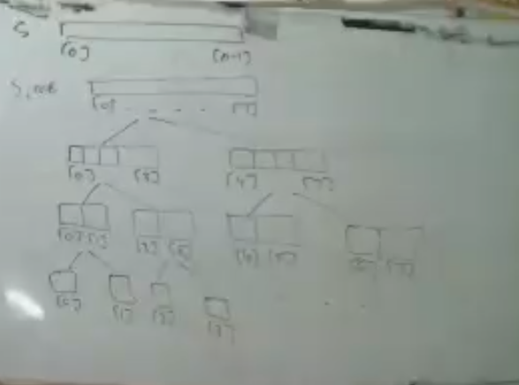
- Little Dark Age
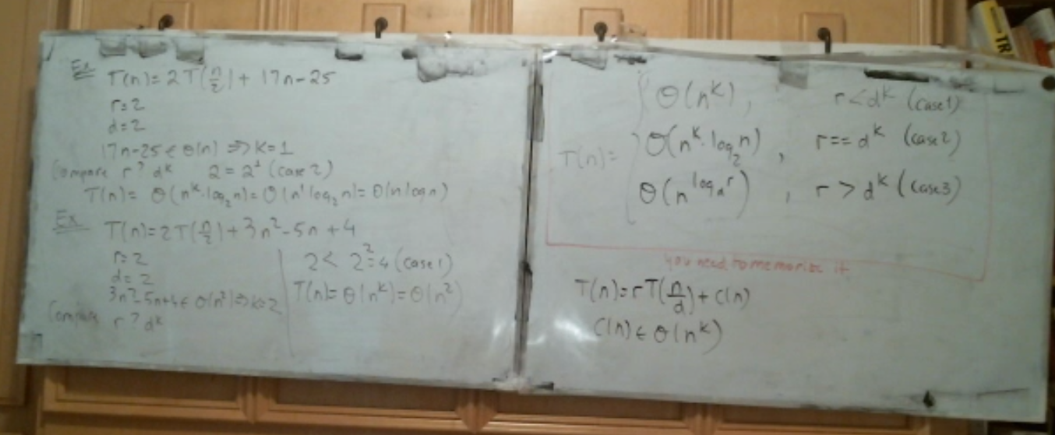
- a
- Hash Tables
- a

